**MongoDB Zen Class Database**

1. Insert to users collection

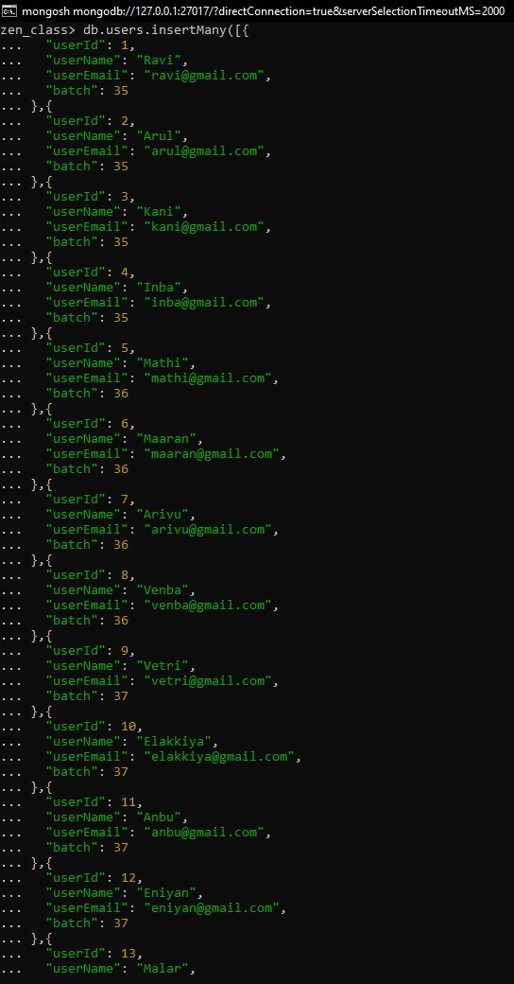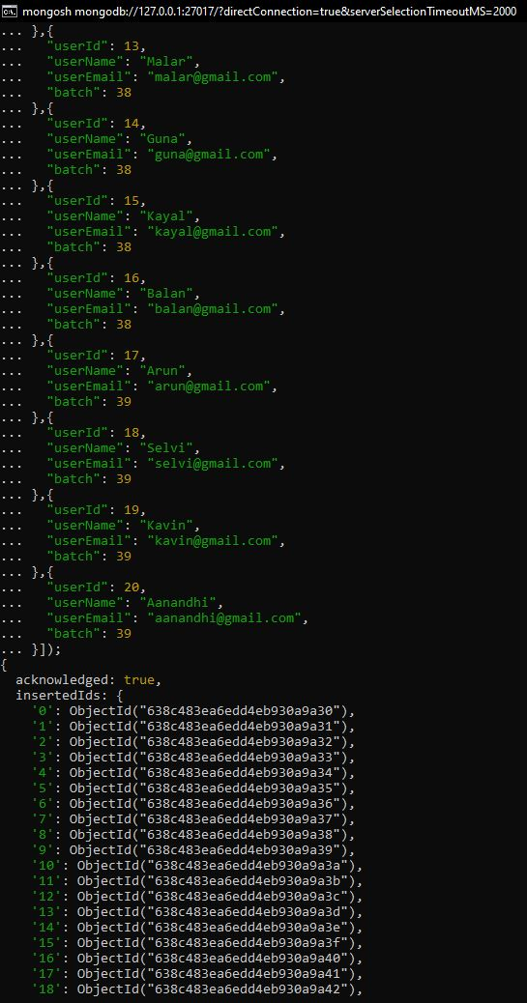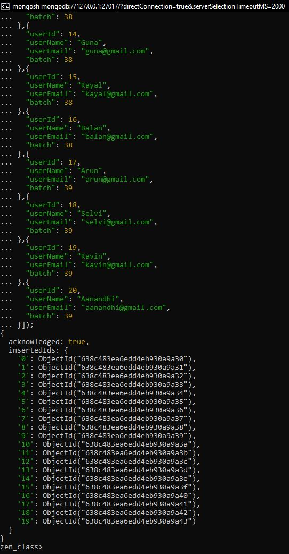

1. Insert to codekata collection

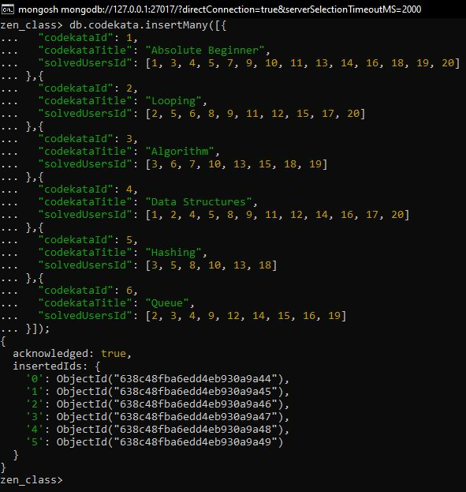

1. Insert to attendance collection

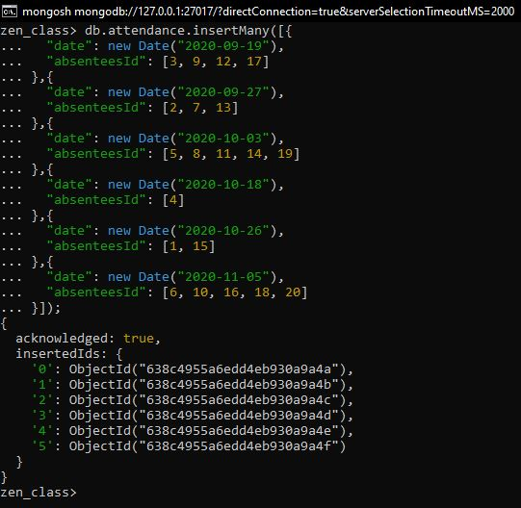

1. Insert to topics collection

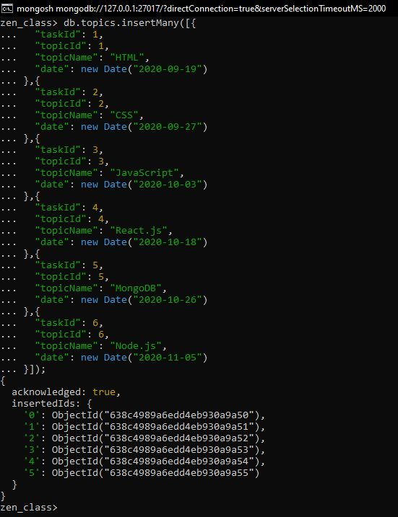

1. Insert to tasks collection

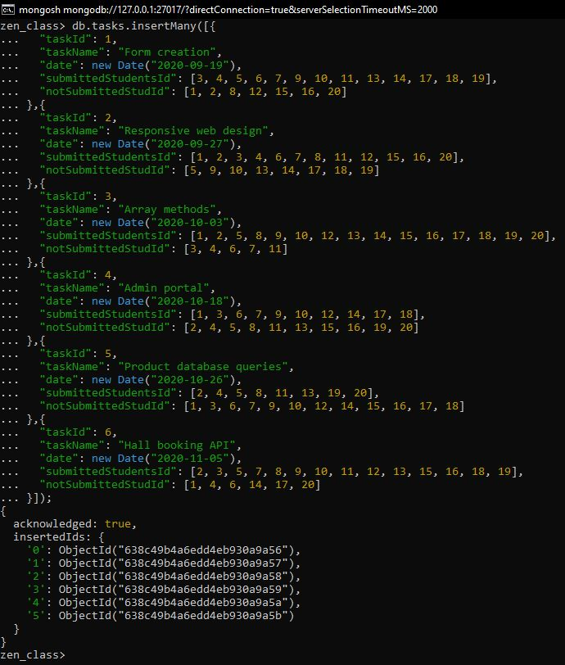

1. Insert to company_drives collection

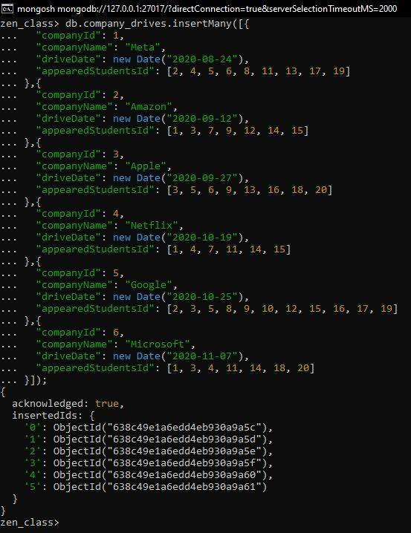

1. Insert to mentors collection

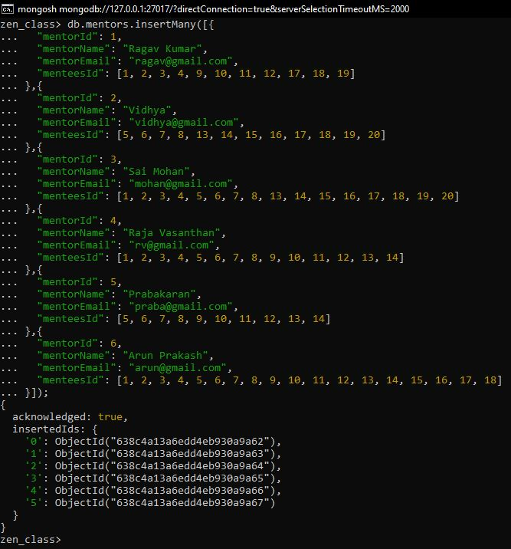

Q1. Find all the topics and tasks which are taught in the month of October

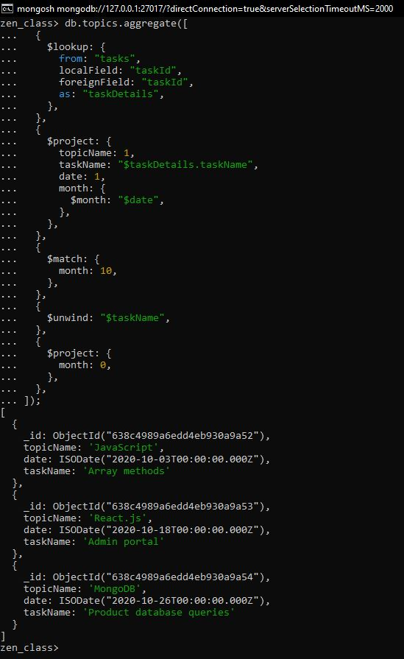

Q2. Find all the company drives which appeared between 15 oct-2020 and 31-oct-2020

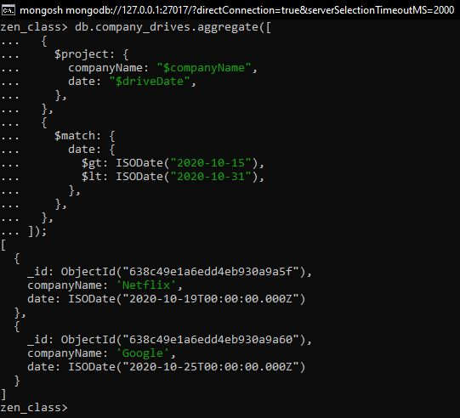

Q3. Find all the company drives and students who are appeared for the placement

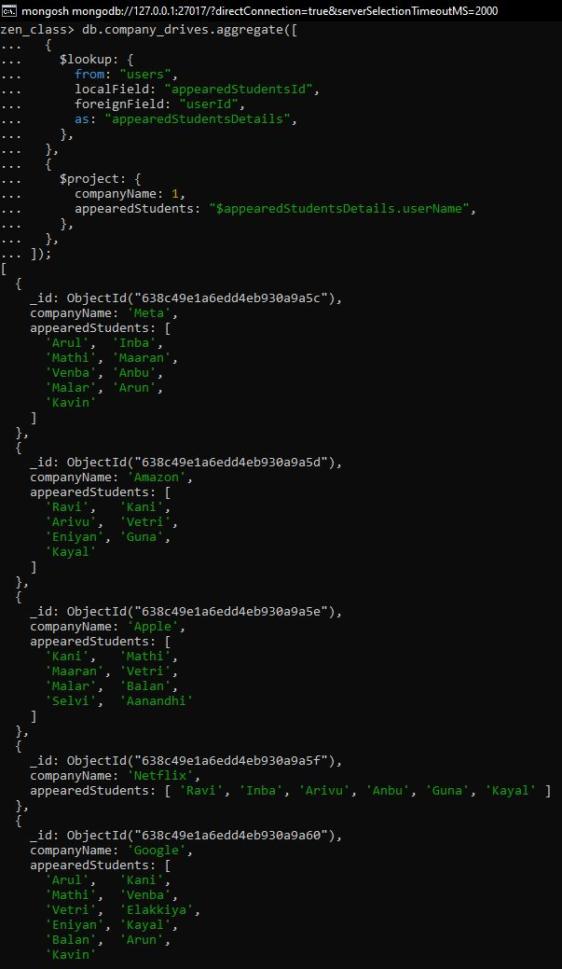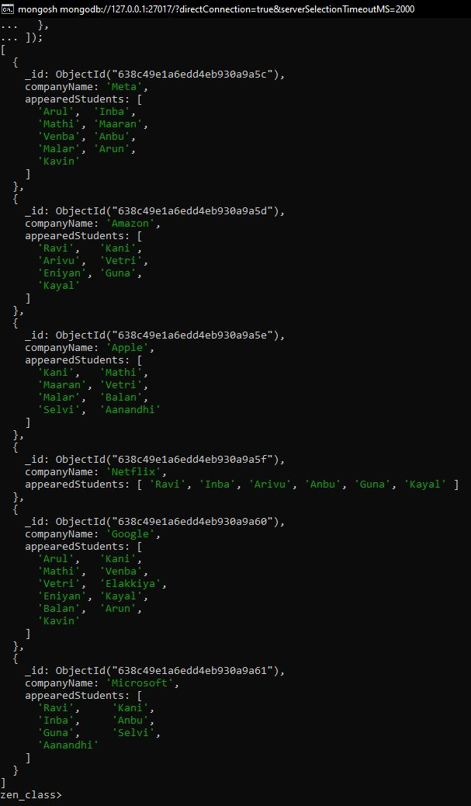

Q4. Find the number of problems solved by the user in codekata

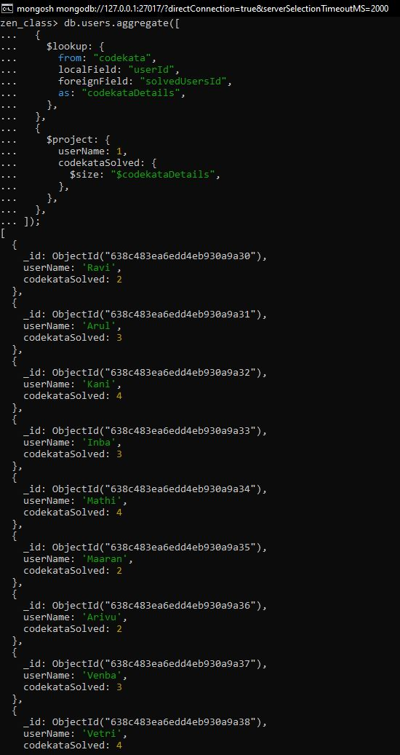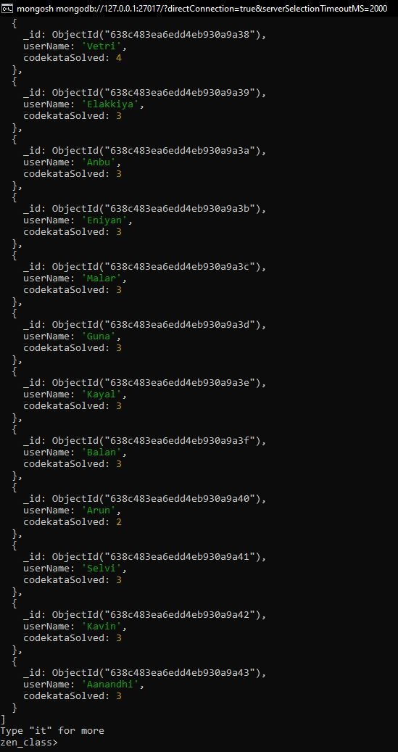

Q5. Find all the mentors with who has the mentee's count more than 15

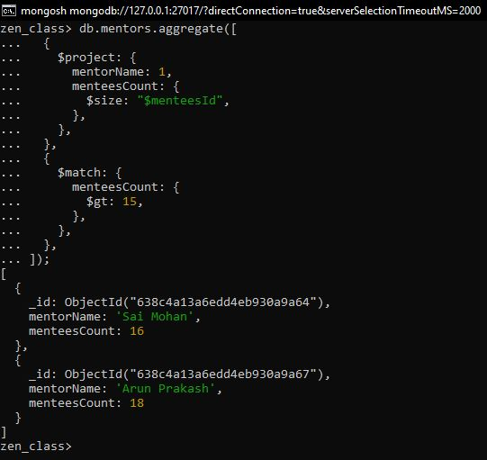

Q6. Find the number of users who are absent and task is not submitted between 15 oct-2020 and 31-oct-2020

